SOP: QA Reports, Hours and Roster
Module | QA Reports, Hours and Roster
Who uses it | QA
Version | 1.0
Issued | 21 Oct 2026
Screenshots are taken from the HRMS test copy. Names, dates and numbers are examples only.

1. Purpose
QA hours are counted from QC work (automatically, from each task's QA hour criteria) plus the non-QC work QA records in My Report. This SOP covers recording that work and the QA reports.

2. My Report - record non-QC work
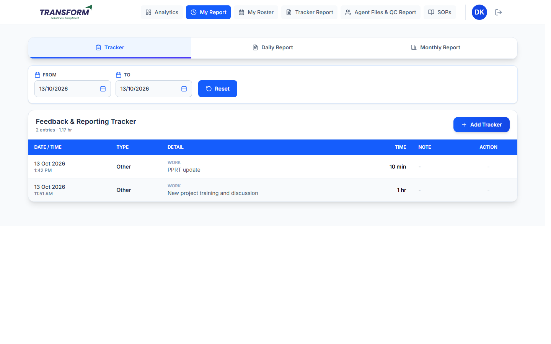
Figure 1: My Report - Feedback & Reporting Tracker
1. Click Add Tracker. The date is today.
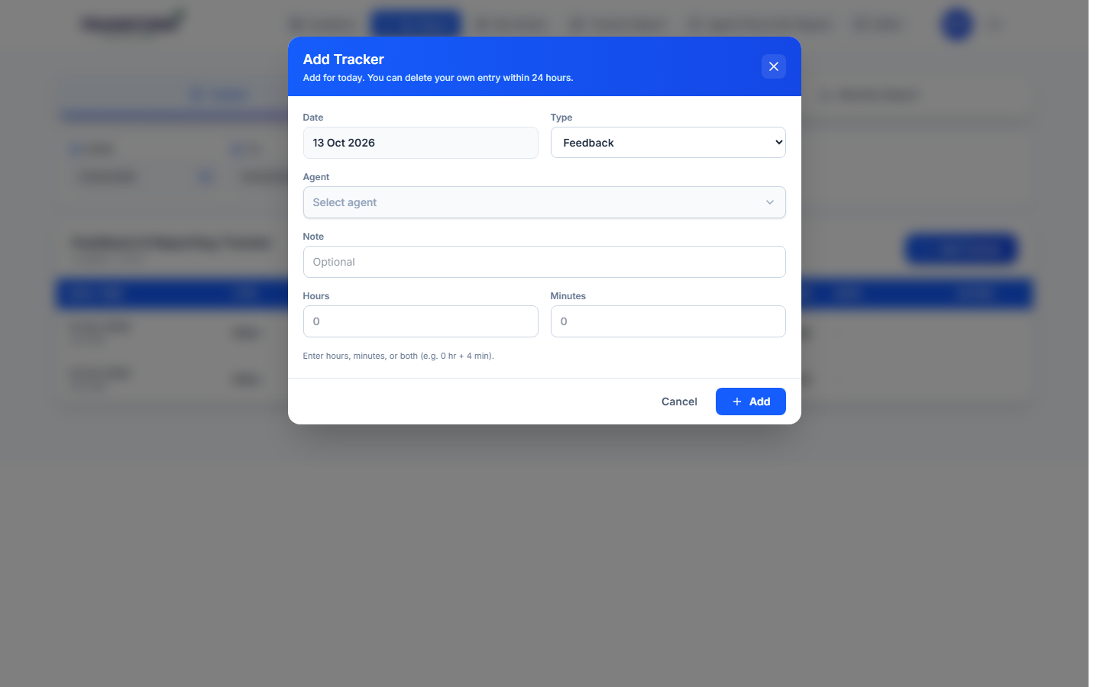
Figure 2: Add Tracker (QA)
2. Choose the Type: Feedback, Training, Reporting or Other.
3. Feedback / Training: choose the Agent (and project) it was for. Reporting / Other: describe the work in 'What did you do'.
4. Enter Hours and/or Minutes (for example 0 hr + 4 min), an optional Note, and click Add.
5. You can delete your own entry within 24 hours.
Daily Report and Monthly Report total your hours: QC hours, rework hours, feedback, reporting and Total / 9 hours.

3. Other screens
Screen | What it shows
Analytics > Overview | Your agents' active count, billable vs assigned hours and latest files for the selected dates (cards explained in SOP - Manager - Reports, section 2).
Tracker Report | Agents' tracker entries. The Task EOD Report tab joins all agents' files for a task and day into one Excel (see SOP - Manager - Reports, section 9).
Agents Billable Report | Agents' billable hours by day and month.
Audit Report | Audits managers did on your QC (audit score vs your score).
KRA | Your monthly KRA.
My Roster | Your schedule.
SOPs | The SOP library (view only).

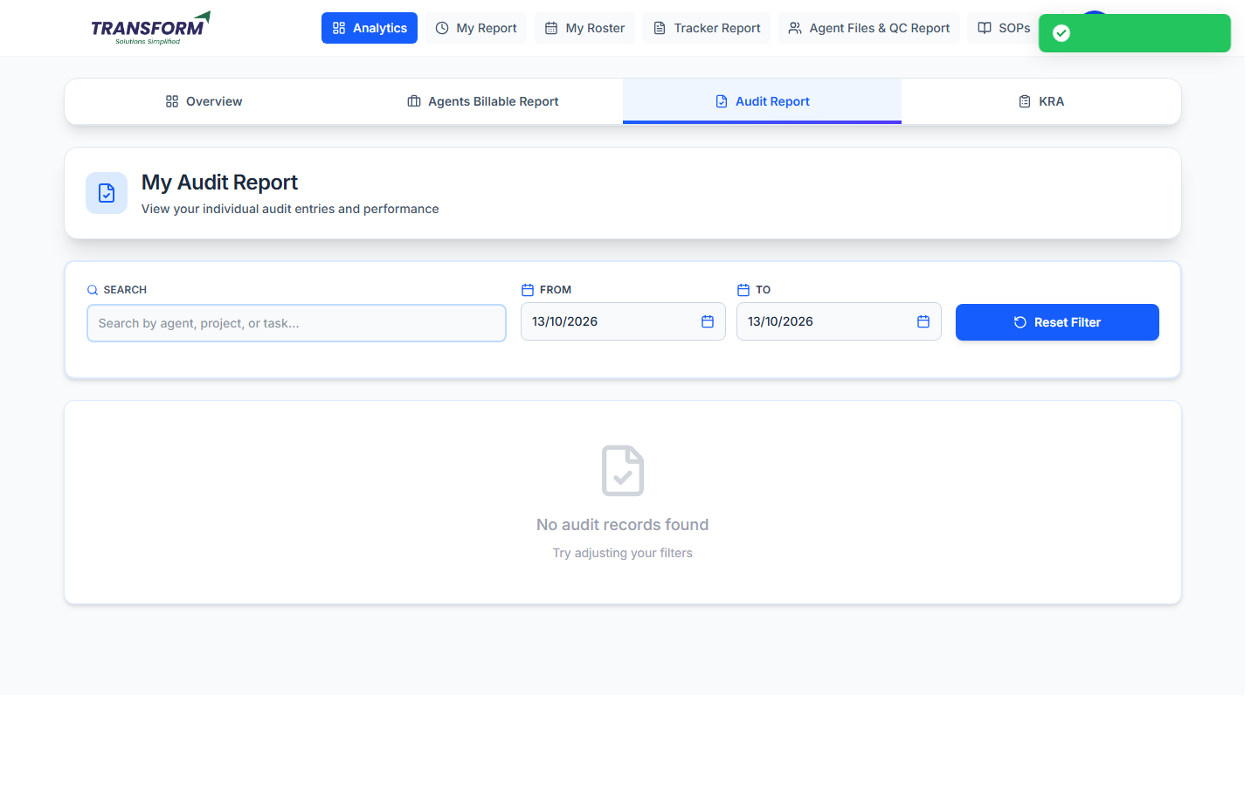
Figure 3: Audit Report
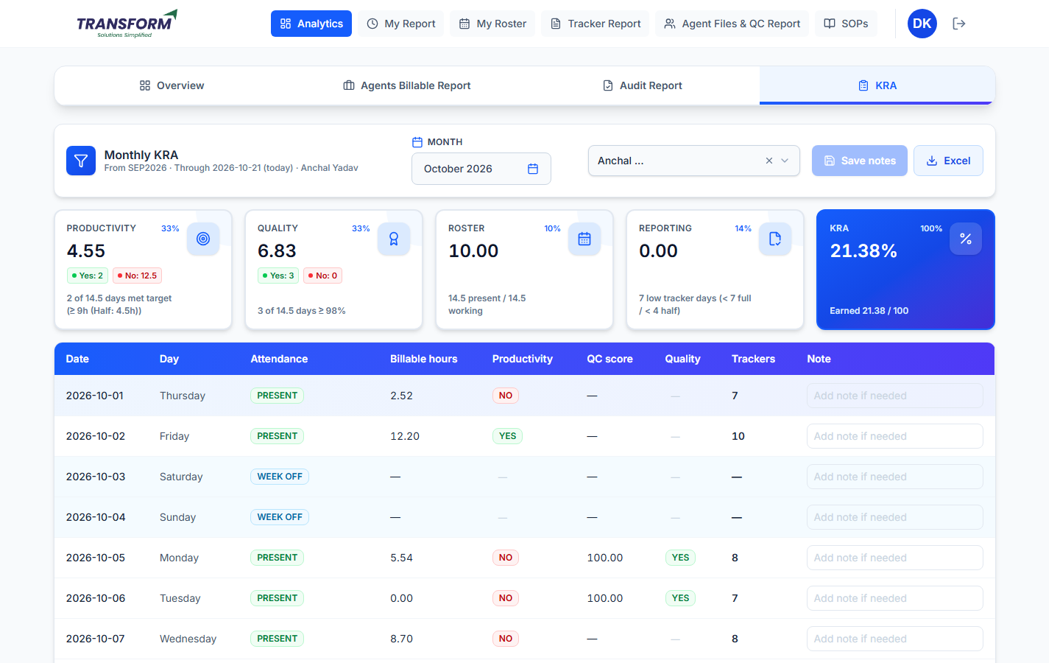
Figure 4: KRA

4. Common problems
Problem | What to do
QC hours look low | QC hours come from the task's QA hour criteria; ask the manager to check the task.
Entry added on the wrong day | Delete it within 24 hours and add it again.

